電通二乙微處理器實驗 實驗結報

實驗名稱 | 四合一七段顯示器
組別 | 21 | 組員 | 陳乙逢

- 實驗目的
使得四合一七段顯示器顯示相應數字

- 實驗步驟
先接電路，在修改程式碼去執行

- 程式碼
（1）
#include "SevSeg.h"

SevSeg sevseg; //Instantiate a seven segment controller object

void setup() {

byte numDigits = 4;

byte digitPins[] = {2, 3, 4, 5};

byte segmentPins[] = {8,9,10,11,12,13,14,15};

bool resistorsOnSegments = false; // 'false' means resistors are on digit pins

byte hardwareConfig = COMMON_CATHODE; // See README.md for options

sevseg.begin(hardwareConfig, numDigits, digitPins, segmentPins, resistorsOnSegments);

sevseg.setBrightness(90);

}

void loop()

{

static unsigned long timer = millis();

static int deciSeconds = 0;

sevseg.setNumber(deciSeconds, 3);

if (millis() - timer >= 50) {

timer += 50;

deciSeconds++;

if (deciSeconds%100 == 59)

{

deciSeconds=deciSeconds+41;

}

else

{

deciSeconds=deciSeconds+1;

}

if (deciSeconds == 2400)

deciSeconds =0 ;

}

sevseg.refreshDisplay(); // Must run repeatedly

}
（2）
#include "SevSeg.h"

SevSeg sevseg;

byte Hour = 0;

byte Min = 0;

void setup() {

byte numDigits = 4;

byte digitPins[] = {2, 3, 4, 5};

byte segmentPins[] = {8, 9, 10, 11, 12, 13, 14, 15};

bool resistorsOnSegments = false; // 'false' means resistors are on digit pins

byte hardwareConfig = COMMON_CATHODE; // See README.md for options

bool updateWithDelays = false; // Default. Recommended

bool leadingZeros = false; // Use 'true' if you'd like to keep the leading zeros

pinMode(6,INPUT);

sevseg.begin(hardwareConfig, numDigits, digitPins, segmentPins, resistorsOnSegments, updateWithDelays, leadingZeros);

sevseg.setBrightness(90);

}

void loop() {

static unsigned long timer = millis();

boolean Pin6= digitalRead (6); // Reset

if (Pin6 == HIGH)

Min = Hour = 0;

if (millis() - timer >= 100) {

timer += 100;

sevseg.setNumber(Hour * 100 + Min, 3);

Min = Min + 1;

if (Min ==60 )

{

Min = 0;

if (Hour == 23)

Hour=0;

else

Hour++;

}

}

sevseg.refreshDisplay(); // Must run repeatedly

}
（3）
#include "SevSeg.h"

SevSeg sevseg;

byte Hour = 0;

byte Min = 0;

void setup() {

byte numDigits = 4;

byte digitPins[] = {2, 3, 4, 5};

byte segmentPins[] = {8, 9, 10, 11, 12, 13, 14, 15};

bool resistorsOnSegments = false; // 'false' means resistors are on digit pins

byte hardwareConfig = COMMON_CATHODE; // See README.md for options

bool updateWithDelays = false; // Default. Recommended

bool leadingZeros = false; // Use 'true' if you'd like to keep the leading zeros

pinMode(6,INPUT);

sevseg.begin(hardwareConfig, numDigits, digitPins, segmentPins, resistorsOnSegments, updateWithDelays, leadingZeros);

sevseg.setBrightness(90);

}

void loop() {

static unsigned long timer = millis();

boolean Pin6= digitalRead (6); // Reset

boolean Pin17= digitalRead (17);

if (Pin6 == HIGH)

Min = Hour = 0;

if (millis() - timer >= 300)

{

timer += 300;

sevseg.setNumber(Hour * 100 + Min, 3);

if(Pin17==HIGH)

{

Min = Min-1;

if(Min==-1)

{

Min=59;

if(Hour==-1)

{

Hour=23;

}

else

Hour--;

}

}

else

{

Min = Min + 1;

if (Min ==60 )

{

Min = 0;

if (Hour == 23)

Hour=0;

else

Hour++;

}

}

}

sevseg.refreshDisplay(); // Must run repeatedly

}

- 實驗結果及分析
使得顯示器能倒數計時和按開關鍵能重新計數

- 心得討論
上網查的更多不同種類程式碼去做測試
- 修正電路圖
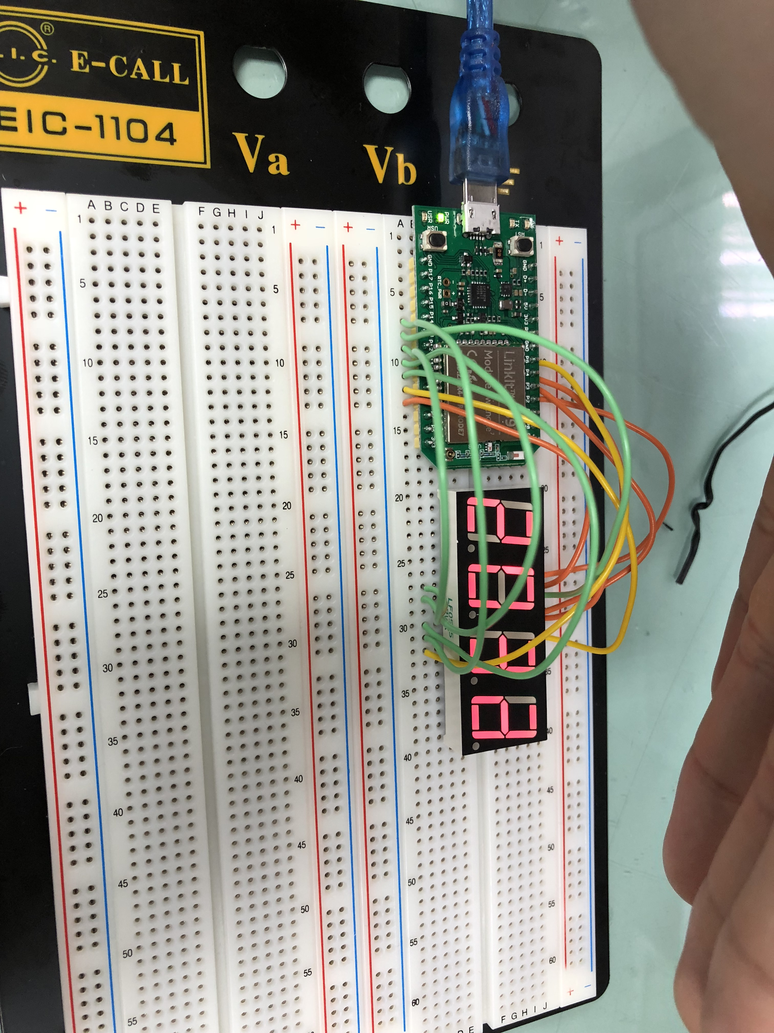

- 修正程式碼
#include "SevSeg.h"

SevSeg sevseg;

byte Hour = 0;

byte Min = 0;

void setup() {

byte numDigits = 4;

byte digitPins[] = {2, 3, 4, 5};

byte segmentPins[] = {8, 9, 10, 11, 12, 13, 14, 15};

bool resistorsOnSegments = false; // 'false' means resistors are on digit pins

byte hardwareConfig = COMMON_CATHODE; // See README.md for options

bool updateWithDelays = false; // Default. Recommended

bool leadingZeros = false; // Use 'true' if you'd like to keep the leading zeros

pinMode(6,INPUT);

sevseg.begin(hardwareConfig, numDigits, digitPins, segmentPins, resistorsOnSegments, updateWithDelays, leadingZeros);

sevseg.setBrightness(90);

}

void loop() {

static unsigned long timer = millis();

boolean Pin6= digitalRead (6); // Reset

boolean Pin17= digitalRead (17);

if (Pin6 == HIGH)

Min = Hour = 0;

if (millis() - timer >= 300)

{

timer += 300;

sevseg.setNumber(Hour * 100 + Min, 3);

if(Pin17==HIGH)

{

Min = Min-1;

if(Min==-1)

{

Min=59;

if(Hour==-1)

{

Hour=23;

}

else

Hour--;

}

}

else

{

Min = Min + 1;

if (Min ==60 )

{

Min = 0;

if (Hour == 23)

Hour=0;

else

Hour++;

}

}

}

sevseg.refreshDisplay(); // Must run repeatedly

}

